Used template - Create a personalized daily newsletter with Google Gemini AI and RSS feeds | n8n workflow template

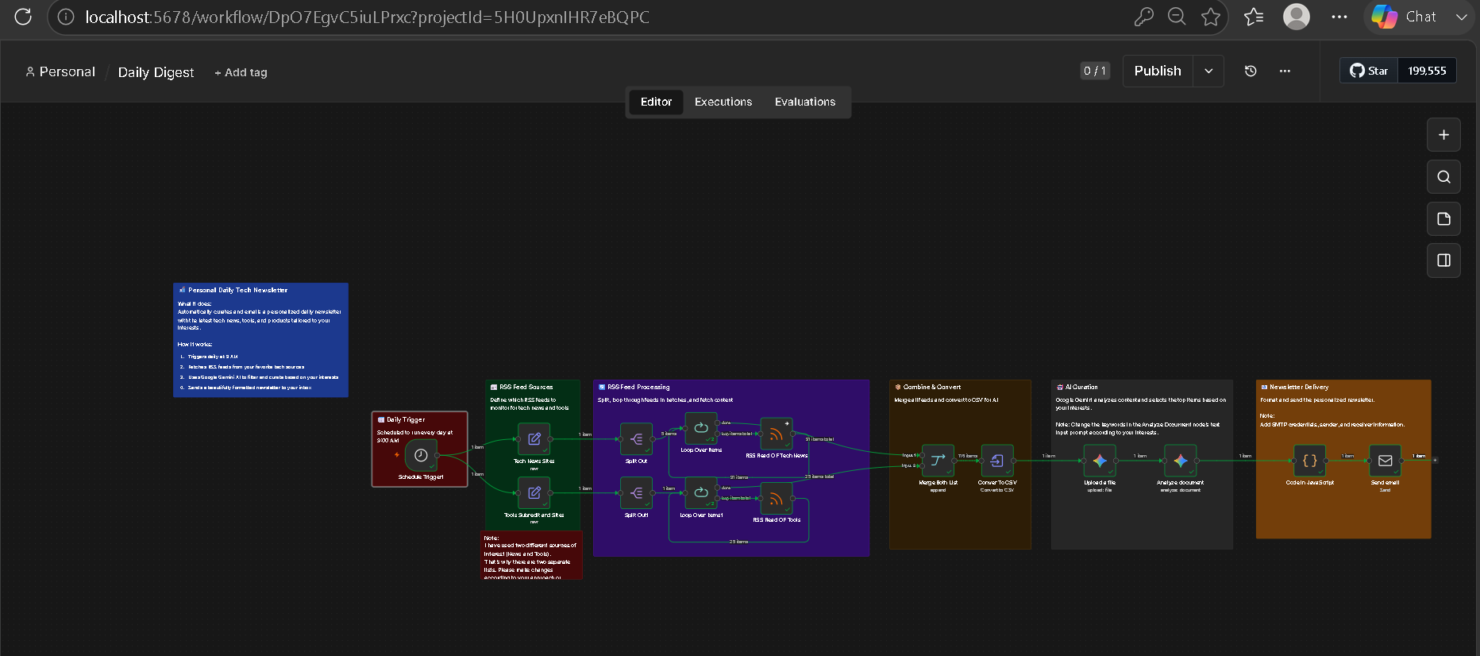

Nodes used are –
1. Schedule Trigger: Runs daily at your chosen time (default: 9:00 AM)
2. RSS Feeds: Fetches content from your favorite news sources and websites
3. Processing: Splits URLs, loops through feeds in batches to avoid rate limits
4. Merge & Convert: Combines all RSS items into a single CSV file
5. AI Curation: Google Gemini analyzes the content and selects relevant items based on your keywords
6. Email Delivery: Sends a personalized HTML newsletter with summaries and images

Prompt :
# Tech Content Writer Prompt

You are a tech content writer.
I have two lists of items:
1️⃣ New Tools & Products
{products_list}
2️⃣ Global & India Tech News
{news_list}

## Task:
- Select the **top 10-15 items** from each list based on these interests and keywords:
- **Tools & Products Keywords:** ["AI", "automation", "developer", "open source", "productivity", "creative", "innovation", "API", "web app", "tools"]
- **News Keywords:** ["technology innovation", "AI breakthrough", "framework", "developer update", "research", "automation trend", "product launch"]
- Keep **two separate sections**:
1. Tools & Products (10-15 items)
2. Global & India Tech Innovations (10-15 items)
- Summarize each item in **2-3 lines**.
- **If an image URL is provided**, display it beautifully under the title with rounded edges
- Tone: "Curious, energetic, and concise – focused on discovery, usefulness, and creativity."
- Format using the HTML template below, replacing placeholder items with actual content from the lists.

Final Email Which is received

